CMPS 183

* **Heading**: Sprint 1 Plan, Draw A Piece, and Completion date: 27 January 2016.
* **Goal:** Have a functioning canvas with all the basic tools needed to draw.
* **Task Listing:**

1. As a user, I would like a basic drawing space so I can draw randomly.

* Set up an empty canvas.(1 hour)
* Set up a marker tool.(1 hour)
* Set up a download button.(1 hour)
* Set up eraser.(1 hour)
* Total time for user story: 3 hours

1. As a user, I would like to control the size of the brush, so that I can draw smaller or bigger as needed.

* Provide a slider to control size.(30 mins)
* Correspond the slider to brush size. (5 hours).
* Total time for user story: 5.5 hours

1. As a user I would like to upload pictures to use on the canvas.

* Set up basic database code. (1.5 hours)
* Save pictures to database. (1 hour)
* Access those saved pictures from the canvas page (1 hour).
* Total time for user story: 3.5 hours
* Team Roles:

1. Raman Nakarmi: Scrum Master, Programmer
2. Daniel Ingersoll: Product Owner, Developer
3. Raul Moncayo: Database programmer
4. Anthony Assi: Programmer
5. Daniel Kimmelmann: Programmer

* Initial Task Assignment:
* Raman Nakarmi: User Story 2 (Task 1 and 2)
* Daniel Ingersoll: User Story 1 (Task 1, 2 and 3), User Story (Task 1)
* Raul Moncayo: User Story 3 (Task 2, and 3)
* Anthony Assi: User Story 1 (Task 2, and 4), User Story 2 (Task 2)
* Daniel Kimmelmann: User Story 2(Task 2)
* 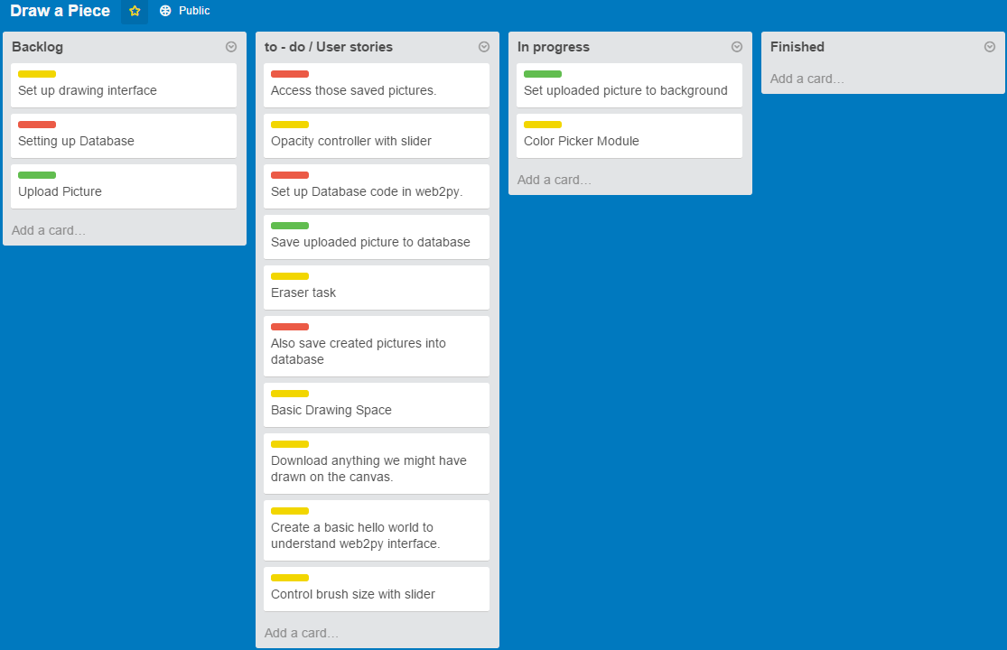Initial Scrum board:
* Scrum Times:
* Monday, Wednesday, Friday: 11:30am